Testing Library:

Install “Wallaby.js” extension ..this will display the test results just beside the test in RED.

It is a library,however we need a Frame work

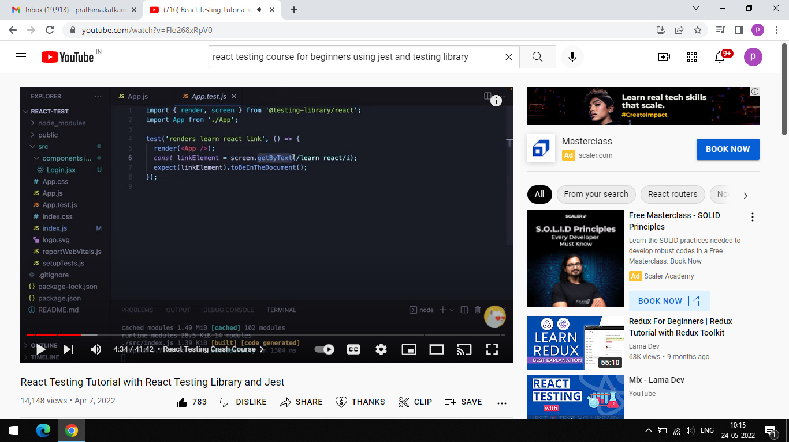

IT tests wheather the link “learn react” exists or not.

$npm run test

Or

$year test

Press a to run all tests

:it shows if it is failed or passed.

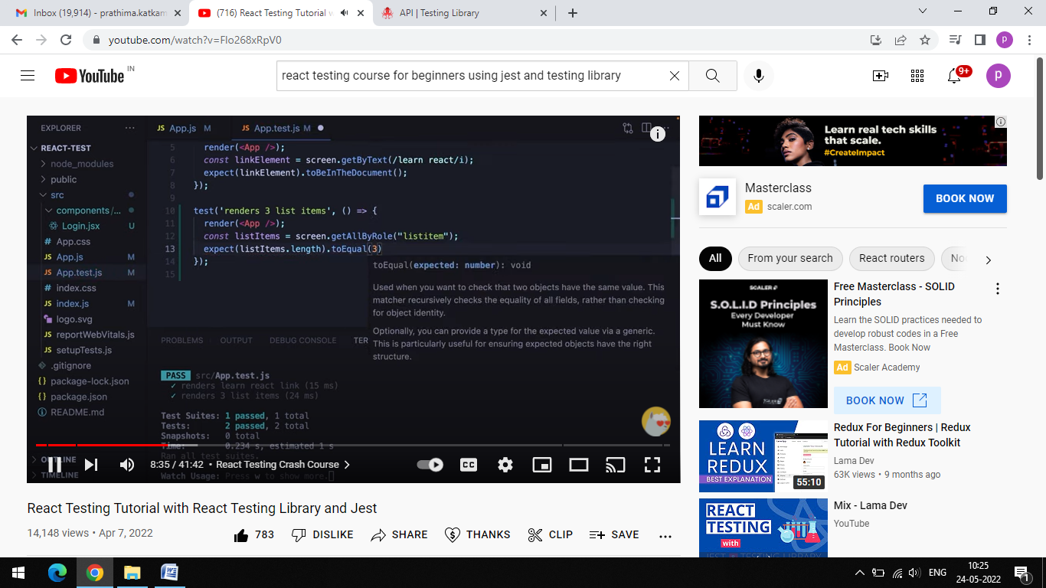

To Check how many lists are there in a list.

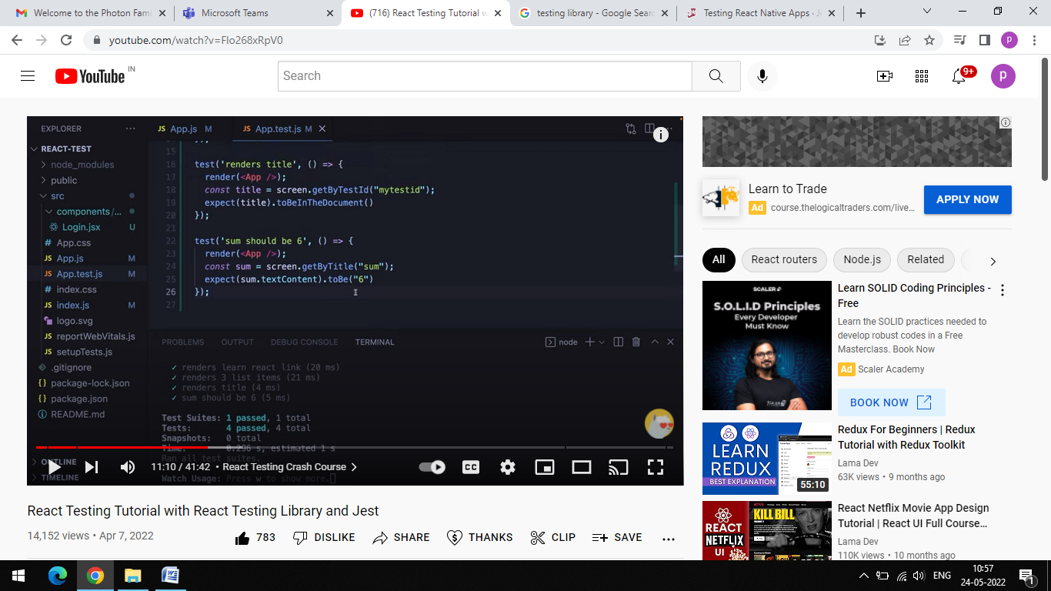

This is used to test sum of 2 different numbers with a title.

Fo r Stripe payment :

https://www.npmjs.com/package/react-stripe-checkout